Kitchen Stuff Volume 1 Help Document

INTRODUCTION

Welcome to the Kitchen Stuff Volume 1 help document. In this document we will go over some of the finer details of the content pack and provide a few ideas to help you get the most out of the items included.

MATERIALS

The pack comes with twelve physically-based rendering materials. They are easily adjusted and instances can be made to create variations of the same items.

Creating and Applying Material Instances

You may not always want all of the same static meshes to look the same. When that happens you can create material instances.

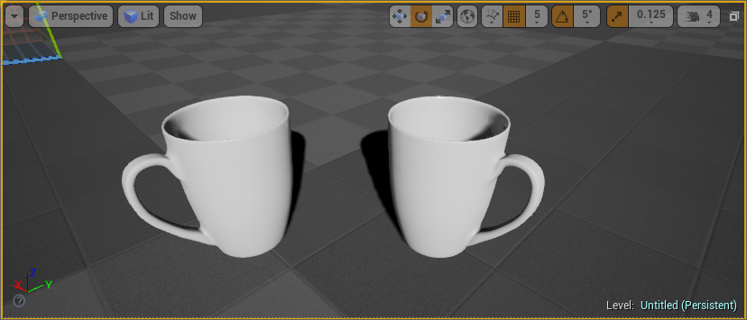
Step 1: In the Content Browser, right-click on the material you want to create an instance of (1.) and then click on Create Material Instance (2.) in the Material Actions menu. A new instance of the material will be created.
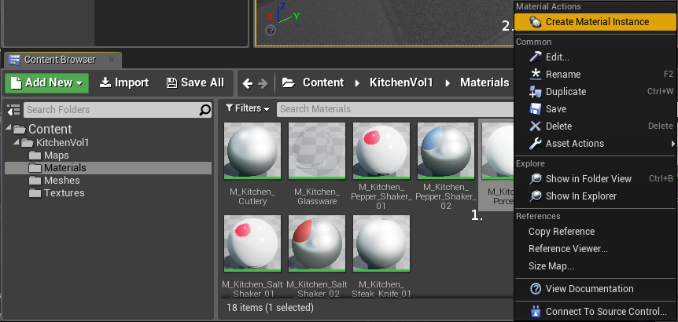
Step 2: Give the instance an appropriate name.

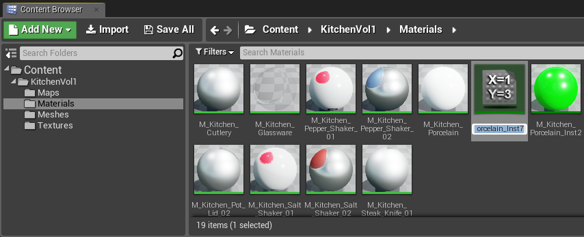
Step 3: Double-click the new material instance to open the Instance Editor.

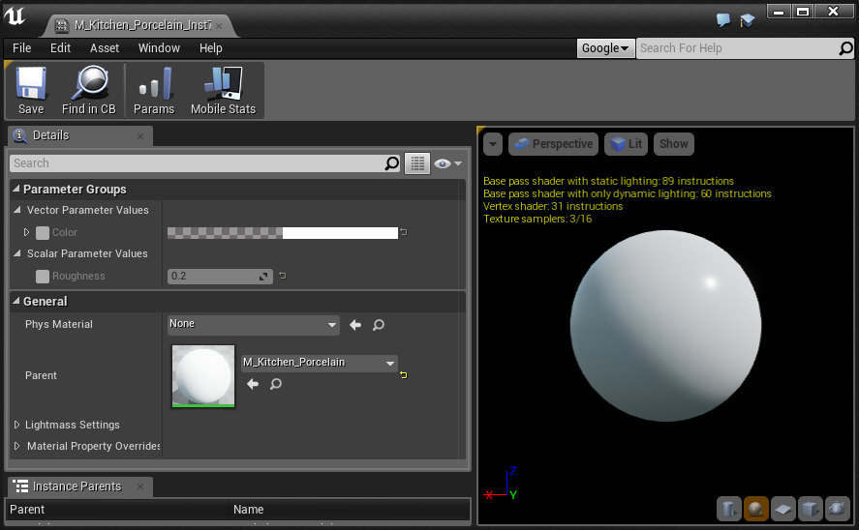
Step 4: Click on the tick-boxes (3.) of the parameters you want to be able to edit to enable them.

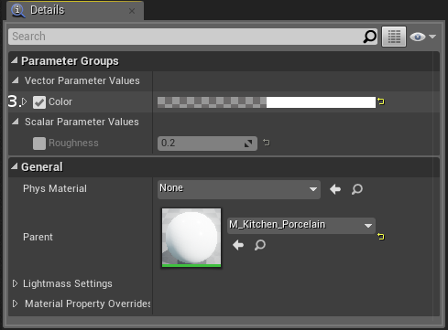
Step 5: Edit the settings you want to change. The settings available will vary from material to material.

Step 6: Once the material instance has been changed to satisfaction, click on the Save button (4.) in the toolbar.

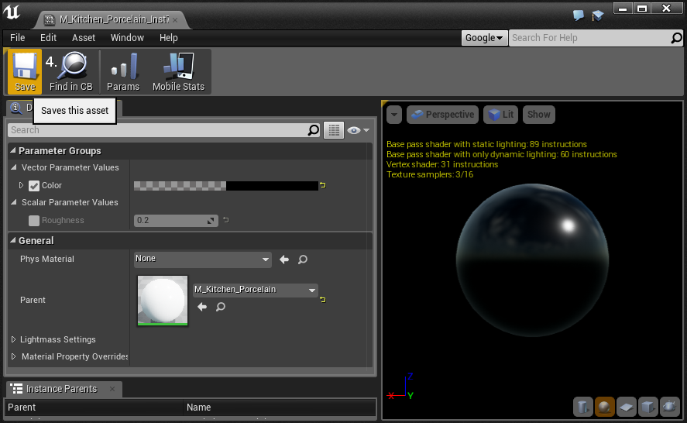
Step 7: Select the static mesh item in your level that you want to apply the material instance to.

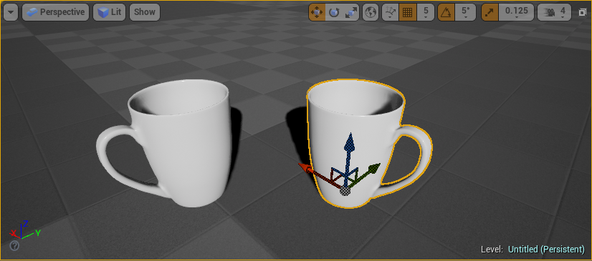
In the Details panel, under Materials, you can see what material is currently applied to the instance of the static mesh.

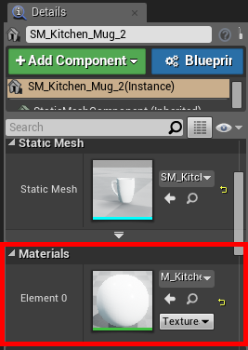

Step 8: Expand the Material drop-down and select the material instance you created.

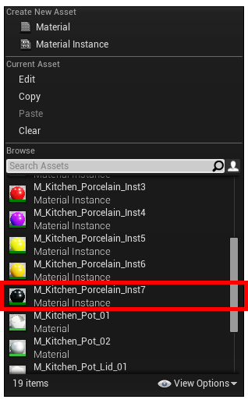
The static mesh instance in your level will now use the new material instance.

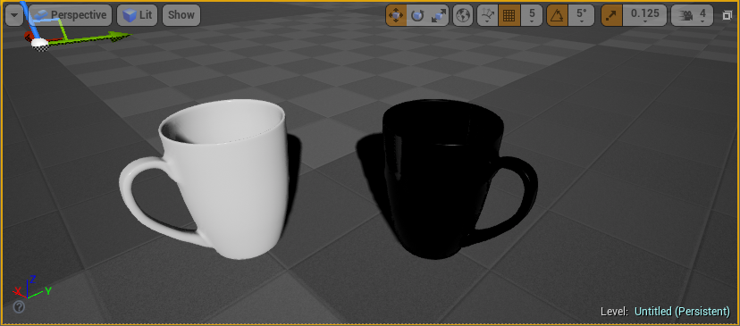
Materials and Static Mesh Pairs

Each static mesh has a specific material that was made for it. Some materials have only one static mesh while others have a few. In the event that the materials become unassigned from their meshes you can reassign them according to the following list:

M_Kitchen_Cutlery

SM_Kitchen_Butter_Knife_01
SM_Kitchen_Fork_01
SM_Kitchen_Tablespoon_01
SM_Kitchen_Teaspoon_01

M_Kitchen_Glassware

SM_Kitchen_Glass_01
SM_Kitchen_Glass_02
SM_Kitchen_Glass_03
SM_Kitchen_Pitcher_01

M_Kitchen_Pepper_Shaker_01

SM_Kitchen_Pepper_Shaker_01

M_Kitchen_Pepper_Shaker_02

SM_Kitchen_Pepper_Shaker_02

M_Kitchen_Porcelain

SM_Kitchen_Cup_Set_01
SM_Kitchen_Cup_Set_02
SM_Kitchen_Milk_Jug_01
SM_Kitchen_Milk_Jug_02
SM_Kitchen_Mug_01
SM_Kitchen_Mug_02
SM_Kitchen_Plate_01
SM_Kitchen_Plate_02
SM_Kitchen_Saucer_01
SM_Kitchen_Saucer_02
SM_Kitchen_Sugar_Bowl_01
SM_Kitchen_Sugar_Bowl_02
SM_Kitchen_Sugar_Bowl_Lid_01
SM_Kitchen_Sugar_Bowl_Lid_02

M_Kitchen_Pot_01

SM_Kitchen_Pot_01

M_Kitchen_Pot_02

SM_Kitchen_Pot_02

M_Kitchen_Pot_Lid_01

SM_Kitchen_Pot_Lid_01

M_Kitchen_Pot_Lid_02

SM_Kitchen_Pot_Lid_02

M_Kitchen_Salt_Shaker_01

SM_Kitchen_Salt_Shaker_01

M_Kitchen_Salt_Shaker_02

SM_Kitchen_Salt_Shaker_02

M_Kitchen_Steak_Knife_01

SM_Kitchen_Steak_Knife_01

Materials and Texture Pairs

Materials use a combination of normal maps, masks and diffuse/color maps. In the event that the textures become unassigned, or you wish to replace them with your own, use the following list to reassign them:

M_Kitchen_Cutlery

T_Kitchen_Noise_D
T_Kitchen_White_Base_1024_M
T_Kitchen_Butter_Knife_01_N

M_Kitchen_Glassware

T_Kitchen_White_Base_1024_M

M_Kitchen_Pepper_Shaker_01

T_Kitchen_Pepper_Shaker_01_M
T_Kitchen_Pepper_Shaker_01_N

M_Kitchen_Pepper_Shaker_02

T_Kitchen_Noise_D
T_Kitchen_Pepper_Shaker_02_M
T_Kitchen_Pepper_Shaker_02_N

M_Kitchen_Porcelain

None

M_Kitchen_Pot_01

T_Kitchen_Noise_D
T_Kitchen_Pot_01_01_M
T_Kitchen_Pot_01_02_M

M_Kitchen_Pot_02

T_Kitchen_Noise_D
T_Kitchen_Pot_02_M
T_Kitchen_Pot_02_N

M_Kitchen_Pot_Lid_01

T_Kitchen_Noise_D
T_Kitchen_Pot_Lid_01_M

M_Kitchen_Pot_Lid_02

T_Kitchen_Noise_D
T_Kitchen_Pot_Lid_02_M
T_Kitchen_Pot_Lid_02_N

M_Kitchen_Salt_Shaker_01

T_Kitchen_Salt_Shaker_01_M
T_Kitchen_Salt_Shaker_01_N

M_Kitchen_Salt_Shaker_02

T_Kitchen_Noise_D
T_Kitchen_Salt_Shaker_02_M
T_Kitchen_Salt_Shaker_02_N

M_Kitchen_Steak_Knife_01

T_Kitchen_Noise_D
T_Kitchen_Steak_Knife_01_M

COLLISION MESHES

The collision meshes that come with the static meshes are quite detailed/complex. The reason for this is to allow for more realistic interactions between items. Hollow items like cups and pots have hollow collision meshes that allow items, like spoons, to fall onto them.

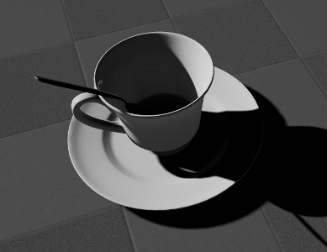
If you do not need that kind of detail, and want to reduce the processing cost per item, you can do the following:

Collision Mesh Replacement

Step 1: Find the item you want to change in the Content Browser tab and right-click on it to open the item menu.

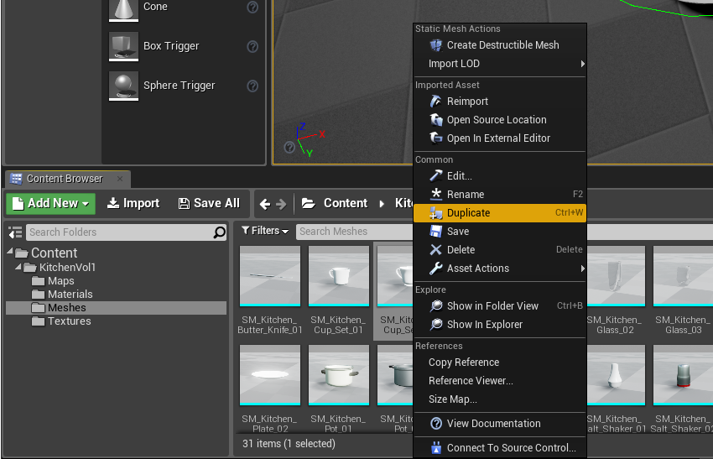
Step 2: Click on Duplicate to create a duplicate of the item. Give the item an appropriate name.

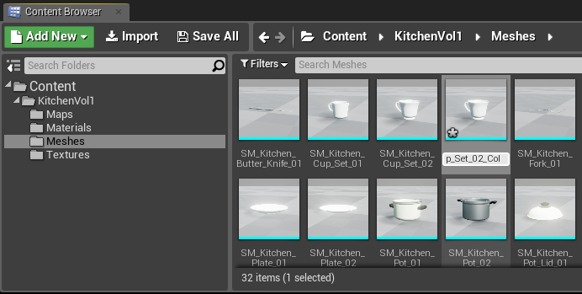
Step 3: Double-click the new item to open the Static Mesh Editor. If the Collision button in the toolbar is highlighted (1.) a light blue collision mesh (2.) will be visible around the static mesh item.
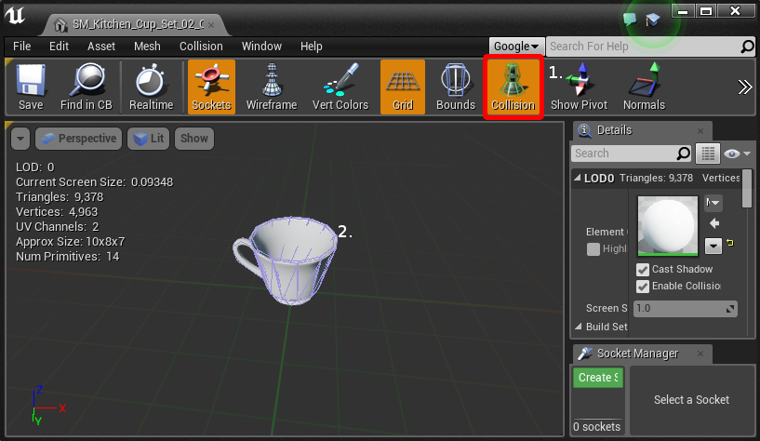
Step 4: Click on Collision (3.) in the menu bar to expand the collision menu and then click on Remove Collision (4.) to remove the current collision mesh.

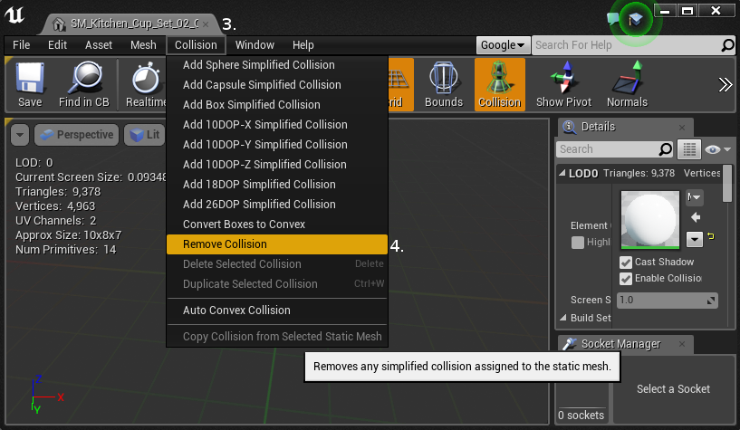
The blue collision mesh should disappear.

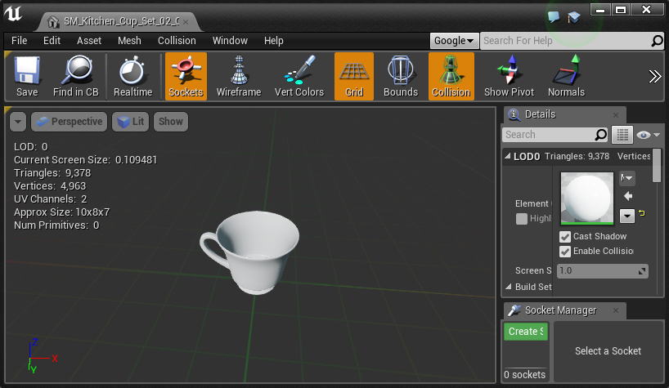
Step 5: Click on Collision in the menu bar again and select the collision mesh type (in the red boxes) you want to add. The collision box that works best depends on the shape of the static mesh and the use you have in mind for it. Luckily it is easy to try them all and find the right one for the situation.

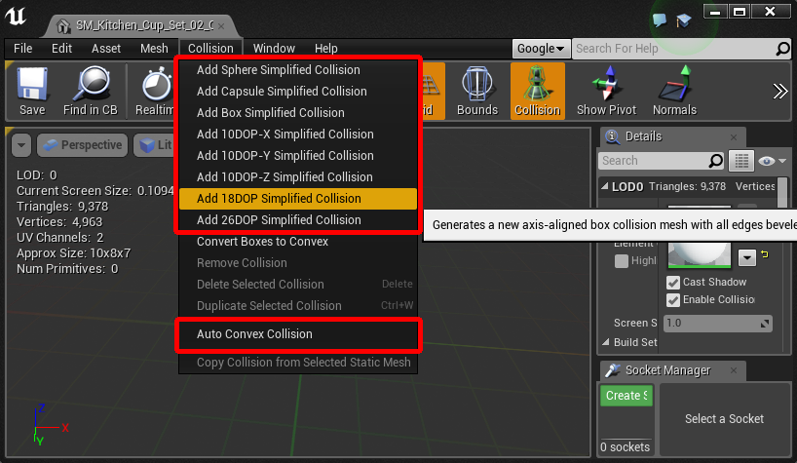

Step 6: Once you have a collision mesh you are happy with, click on the Save button (5.) in the toolbar.

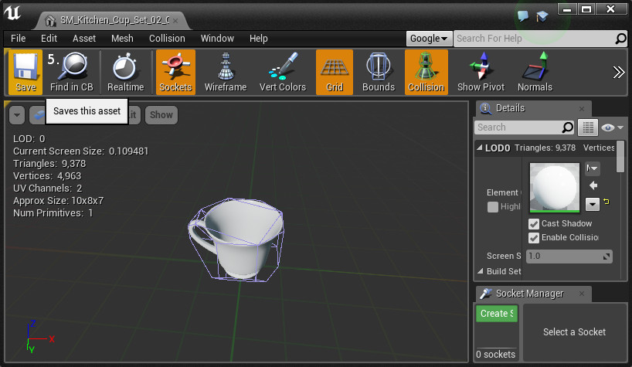
FURTHER QUESTIONS

For additional queries, contact us at support@tijgergames.com.

